# Send alert by Email after Failover event

## First of all, is needed to configure database mail

|  |
| --- |
| Configuration of the profile in Database mail |

## Send an email once occurs a Failover Event

|  |
| --- |
| General Tab Error number 1480 (also called Replication Database Role Change), referenced above, represents information that the FCI database failed to change its expected role during the failover process or, in other words, the switching was unsuccessful due to unavailability of the particular database   Responses tab  Options Tab |

## Checking Synchronization of the databases

|  |
| --- |
| SELECT database_name,  is_failover_ready  FROM sys.dm_hadr_database_replica_cluster_states  WHERE replica_id IN (  SELECT replica_id  FROM sys.dm_hadr_availability_replica_states  )  *The value ‘0’ means that the availability databases are not synchronized* |

## Check which FCI node is active (T-SQL)

|  |
| --- |
| SELECT NodeName,  STATUS AS NodeStatus,  status_description AS NodeStatusDescription,  is_current_owner AS CurrentlyActiveNode  FROM sys.dm_os_cluster_nodes |

|  |
| --- |
| SELECT * FROM sys.dm_server_services |

Alerts created

|  |
| --- |
| --Create SQL Server Alert for AlwaysOn Role Change  EXEC msdb.dbo.sp_add_alert  @name=N'AlwaysOn - Role Change',  @message_id=1480,  @severity=0,  @enabled=1,  @delay_between_responses=0,  @include_event_description_in=0,  @category_name=N'[Uncategorized]',  @job_id=N'00000000-0000-0000-0000-000000000000'  GO  --Create SQL Server Alert for AlwaysOn Data Movement Suspended  EXEC msdb.dbo.sp_add_alert  @name=N'AlwaysOn - Data Movement Suspended',  @message_id=35264,  @severity=0,  @enabled=1,  @delay_between_responses=0,  @include_event_description_in=0,  @category_name=N'[Uncategorized]',  @job_id=N'00000000-0000-0000-0000-000000000000'  GO  --Create SQL Server Alert for AlwaysOn Data Movement Resumed  EXEC msdb.dbo.sp_add_alert  @name=N'AlwaysOn - Data Movement Resumed',  @message_id=35265,  @severity=0,  @enabled=1,  @delay_between_responses=0,  @include_event_description_in=0,  @category_name=N'[Uncategorized]',  @job_id=N'00000000-0000-0000-0000-000000000000'  GO  EXEC msdb.dbo.sp_add_alert @name=N'HA Error - 35273',  @message_id=35273,  @severity=0,  @enabled=1,  @delay_between_responses=0,  @include_event_description_in=1,  @job_id=N'00000000-0000-0000-0000-000000000000'  GO  EXEC msdb.dbo.sp_add_alert @name=N'HA Error - 35274',  @message_id=35274,  @severity=0,  @enabled=1,  @delay_between_responses=0,  @include_event_description_in=1,  @job_id=N'00000000-0000-0000-0000-000000000000'  GO  EXEC msdb.dbo.sp_add_alert @name=N'HA Error - 35275',  @message_id=35275,  @severity=0,  @enabled=1,  @delay_between_responses=0,  @include_event_description_in=1,  @job_id=N'00000000-0000-0000-0000-000000000000'  GO  EXEC msdb.dbo.sp_add_alert @name=N'HA Error - 35254',  @message_id=35254,  @severity=0,  @enabled=1,  @delay_between_responses=0,  @include_event_description_in=1,  @job_id=N'00000000-0000-0000-0000-000000000000'  GO  EXEC msdb.dbo.sp_add_alert @name=N'HA Error - 35279',  @message_id=35279,  @severity=0,  @enabled=1,  @delay_between_responses=0,  @include_event_description_in=1,  @job_id=N'00000000-0000-0000-0000-000000000000'  GO  EXEC msdb.dbo.sp_add_alert @name=N'HA Error - 35262',  @message_id=35262,  @severity=0,  @enabled=1,  @delay_between_responses=0,  @include_event_description_in=1,  @job_id=N'00000000-0000-0000-0000-000000000000'  GO  EXEC msdb.dbo.sp_add_alert @name=N'HA Error - 35276',  @message_id=35276,  @severity=0,  @enabled=1,  @delay_between_responses=0,  @include_event_description_in=1,  @job_id=N'00000000-0000-0000-0000-000000000000'  GO |

Testing the errors

|  |
| --- |
| RAISERROR(35254,10,1) WITH LOG; |

|  |
| --- |
| --1 crear tabla  create table FailoverEvent  (  mainserver varchar(50)  )  --create sp  create procedure dbo.SP_failover  as  insert into FailoverEvent (mainserver) values ('SQL2');  --3 run sp  exec dbo.SP_failover  select * from FailoverEvent  delete from FailoverEvent |

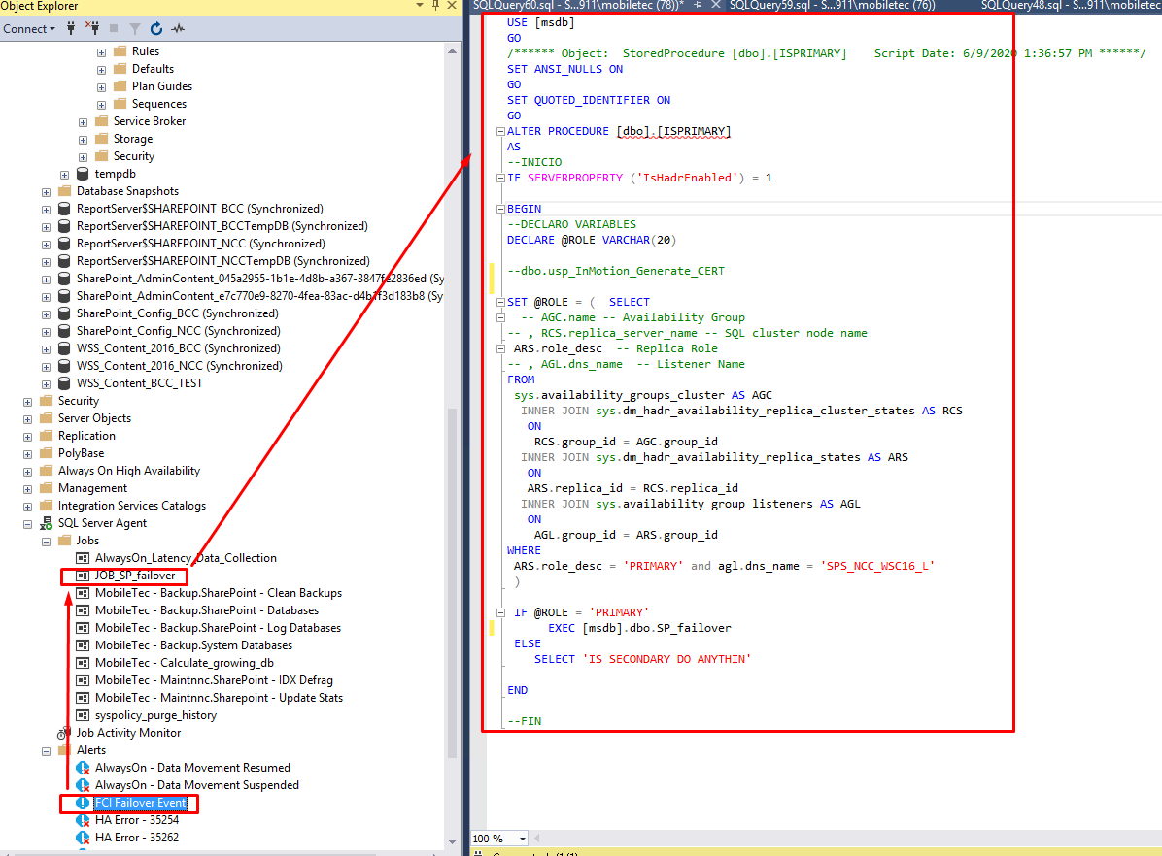

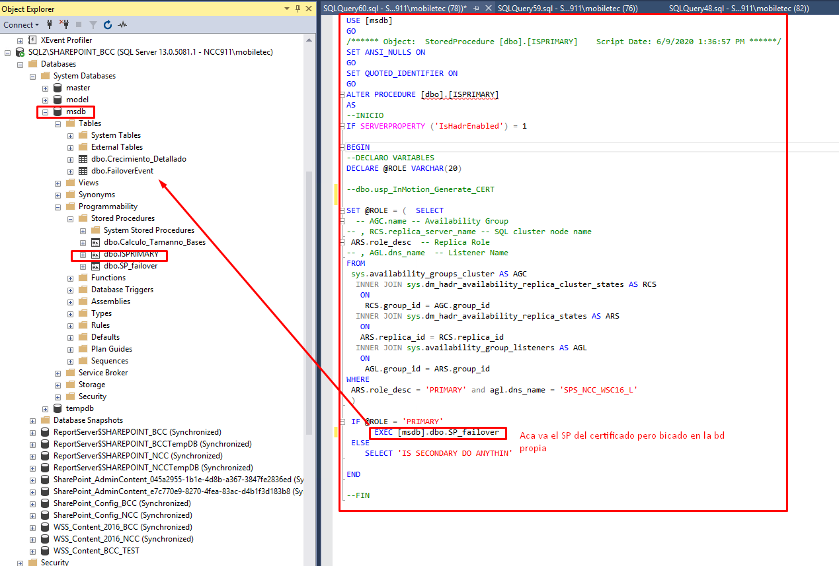

## Monitoring Availability Groups on the WSFC Cluster

|  |
| --- |
| select * from sys.availability_group_listener_ip_addresses    select * from sys.availability_group_listeners    select * from sys.dm_tcp_listener_states |

Verificar que se ha creado la clave maestra de datos:

|  |
| --- |
| SELECT name KeyName,  symmetric_key_id KeyID,  key_length KeyLength,  algorithm_desc KeyAlgorithm  FROM sys.symmetric_keys; |

## Monitoring Availability Groups on the WSFC Cluster

|  |
| --- |
| Quorum status  select * from sys.dm_hadr_cluster    select * from sys.dm_hadr_cluster_members    Instancias  select * from sys.dm_hadr_instance_node_map |

## Monitoring Availability Groups

<https://docs.microsoft.com/en-us/sql/database-engine/availability-groups/windows/monitor-availability-groups-transact-sql?view=sql-server-ver15#WSFC>

|  |
| --- |
| select * from sys.availability_groups |

## Monitoring Availability Databases

|  |
| --- |
| select * from sys.availability_databases_cluster    select * from sys.databases |

<https://www.mssqltips.com/sqlservertip/3489/configure-sql-server-alerts-and-notifications-for-alwayson-availability-groups/>

<https://docs.microsoft.com/en-us/sql/database-engine/availability-groups/windows/always-on-extended-events?view=sql-server-ver15>

<https://www.mssqltips.com/sqlservertip/2973/configuring-alerts-for-sql-server-alwayson-availability-groups/>

<https://www.connectionstrings.com/sql-server/>

**How to know the main replica**

<https://www.mssqltips.com/sqlservertip/3206/finding-primary-replicas-for-sql-server-2012-alwayson-availability-groups-with-powershell/>

<https://www.mssqltips.com/sqlservertip/2573/monitor-sql-server-alwayson-availability-groups/>

<https://www.mssqltips.com/sqlservertip/2973/configuring-alerts-for-sql-server-alwayson-availability-groups/>

|  |
| --- |
| IF SERVERPROPERTY ('IsHadrEnabled') = 1  BEGIN  SELECT  AGC.name -- Availability Group  , RCS.replica_server_name -- SQL cluster node name  , ARS.role_desc -- Replica Role  , AGL.dns_name -- Listener Name  FROM  sys.availability_groups_cluster AS AGC  INNER JOIN sys.dm_hadr_availability_replica_cluster_states AS RCS  ON  RCS.group_id = AGC.group_id  INNER JOIN sys.dm_hadr_availability_replica_states AS ARS  ON  ARS.replica_id = RCS.replica_id  INNER JOIN sys.availability_group_listeners AS AGL  ON  AGL.group_id = ARS.group_id  WHERE  ARS.role_desc = 'PRIMARY'  END |

|  |
| --- |
| IF SERVERPROPERTY ('IsHadrEnabled') = 1  BEGIN  SELECT  AGC.name -- Availability Group  , RCS.replica_server_name -- SQL cluster node name  , ARS.role_desc -- Replica Role  , AGL.dns_name -- Listener Name  FROM  sys.availability_groups_cluster AS AGC  INNER JOIN sys.dm_hadr_availability_replica_cluster_states AS RCS  ON  RCS.group_id = AGC.group_id  INNER JOIN sys.dm_hadr_availability_replica_states AS ARS  ON  ARS.replica_id = RCS.replica_id  INNER JOIN sys.availability_group_listeners AS AGL  ON  AGL.group_id = ARS.group_id  WHERE  ARS.role_desc = 'PRIMARY' and agl.dns_name = 'SPS_NCC_WSC16_L'  END  -----  select synchronization_state, synchronization_state_desc, * from sys.dm_hadr_database_replica_states |

select * from sys.availability_groups_cluster

SELECT group_id, * FROM sys.availability_groups_cluster

SELECT group_id, replica_id, * FROM sys.dm_hadr_availability_replica_cluster_states

SELECT replica_id, group_id, role_desc, * FROM sys.dm_hadr_availability_replica_states where role_desc = 'PRIMARY'

SELECT group_id, dns_name, * FROM sys.availability_group_listeners where dns_name = 'SPS_NCC_WSC16_L'

|  |
| --- |
| SELECT role_desc FROM sys.dm_hadr_availability_replica_states where role_desc = 'PRIMARY'  SELECT dns_name, * FROM sys.availability_group_listeners where dns_name = 'SPS_NCC_WSC16_L'  DECLARE @ROLE VARCHAR(10)  SET @ROLE = (SELECT role_desc FROM sys.dm_hadr_availability_replica_states where role_desc = 'PRIMARY')  IF @ROLE = 'PRIMARY'  SELECT 'PRINCIPAL'  ELSE  SELECT 'SECONDARY' |

|  |
| --- |
| IF SERVERPROPERTY ('IsHadrEnabled') = 1  BEGIN  --DECLARO VARIABLES  DECLARE @ROLE VARCHAR(20)  SET @ROLE = ( SELECT  -- AGC.name -- Availability Group  -- , RCS.replica_server_name -- SQL cluster node name  ARS.role_desc -- Replica Role  -- , AGL.dns_name -- Listener Name  FROM  sys.availability_groups_cluster AS AGC  INNER JOIN sys.dm_hadr_availability_replica_cluster_states AS RCS  ON  RCS.group_id = AGC.group_id  INNER JOIN sys.dm_hadr_availability_replica_states AS ARS  ON  ARS.replica_id = RCS.replica_id  INNER JOIN sys.availability_group_listeners AS AGL  ON  AGL.group_id = ARS.group_id  WHERE  ARS.role_desc = 'PRIMARY' and agl.dns_name = 'SPS_NCC_WSC16_L'  )  IF @ROLE = 'PRIMARY'  SELECT 'IS PRIMARY RUN SP CERTIFICATE'  ELSE  SELECT 'IS SECONDARY DO ANYTHIN'  END |

SP ISPRIMARY

|  |
| --- |
| CREATE PROCEDURE ISPRIMARY  AS  --INICIO  IF SERVERPROPERTY ('IsHadrEnabled') = 1  BEGIN  --DECLARO VARIABLES  DECLARE @ROLE VARCHAR(20)  SET @ROLE = ( SELECT  -- AGC.name -- Availability Group  -- , RCS.replica_server_name -- SQL cluster node name  ARS.role_desc -- Replica Role  -- , AGL.dns_name -- Listener Name  FROM  sys.availability_groups_cluster AS AGC  INNER JOIN sys.dm_hadr_availability_replica_cluster_states AS RCS  ON  RCS.group_id = AGC.group_id  INNER JOIN sys.dm_hadr_availability_replica_states AS ARS  ON  ARS.replica_id = RCS.replica_id  INNER JOIN sys.availability_group_listeners AS AGL  ON  AGL.group_id = ARS.group_id  WHERE  ARS.role_desc = 'PRIMARY' and agl.dns_name = 'SPS_NCC_WSC16_L'  )  IF @ROLE = 'PRIMARY'  EXEC DBO.SP_failover  ELSE  SELECT 'IS SECONDARY DO ANYTHIN'  END  --FIN  GO |

SELECT name KeyName,

symmetric_key_id KeyID,

key_length KeyLength,

algorithm_desc KeyAlgorithm

FROM sys.symmetric_keys;